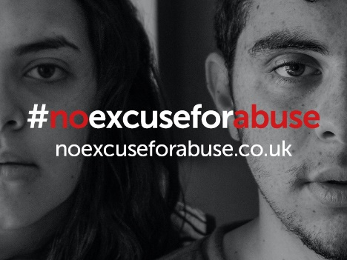
DOMESTIC ABUSE FACTSHEET FOR EMPLOYERS
Domestic abuse isn’t just physical – it can be emotional, physical, sexual, financial or controlling behaviour.
Anyone can be affected by domestic abuse and it can happen in all types of relationships - couples, parents, grandparents or wider family members.
It is a massive health and wellbeing issue and its impact on employees in the workplace can often go unnoticed - overlooked by managers and employers who have yet to make the potential connection between domestic abuse and a person’s behaviour or performance in the workplace.
For many victims of domestic abuse, the workplace offers a shelter from the abuse and it is often here, through the support of their line manager, colleagues and support services such as Occupational Health that victims choose to take the first steps to safety.
Recognising the signs of domestic abuse
It is very difficult to create a definitive list of signs that domestic abuse is happening because abuse can occur on many levels and both victims and alleged or known perpetrators can behave and respond in a range of different ways. The following list of signs of behaviour for victims is not exhaustive, and should not be used as a definitive list but should be used as guidance:
- Has unexplained bruises or injuries
- Shows signs of feeling suicidal
- Becomes unusually quiet or withdrawn
- Has panic attacks
- Has frequent absences from work or other commitments
- Wears clothes that conceal even on warm days
- Stops talking about her/his partner
- Is anxious about being out or rushes away
- May never be seen alone, and is always accompanied by their partner
- May become more isolated, possibly moving away from home, withdrawing from friends and family
- Go along with everything their partner says and does
- Check in often with their partner to report where they are and what they’re doing
- Receive frequent, harassing phone calls from their partner
- May have unexplained injuries, and may give other reasons for the injuries which refer to them being accidental

The Department of Health, together with domestic abuse charity Safe Lives, have created a practical guide for line managers, Human Resources and Employee Assistance Programmes to help employers effectively support colleagues experiencing domestic abuse. Download the guide here: Responding to colleagues experiencing domestic abuse: Practical guidance for line managers, Human Resources and Employee Assistance Programmes

Need more advice?
PLEASE INSERT HERE WHICH IS THE MOST APPROPRIATE ROUTE MANAGERS CAN GET ADVICE RE DOMESTIC ABUSE AND ITS EFFECTS ON EMPLOYEES, FOR EXAMPLE HR OR OCCUPATIONAL HEALTH.
Help and support services
If a person you manage needs support regarding domestic abuse, you can visit www.noexcuseforabuse.co.uk for details of the agencies in Lancashire who can help them.
If you believe there is an immediate risk of harm to someone, or it is an emergency, you should always dial 999.

