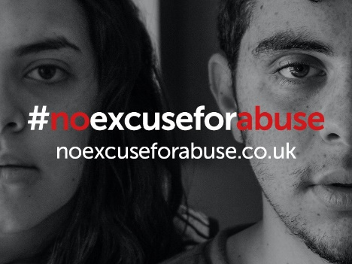
DOMESTIC ABUSE PROFESSIONALS AT C-19 TESTING SITES FACTSHEET
How to respond to a domestic abuse disclosure at COVID-19 testing sites
All professionals have an obligation to safeguard vulnerable adults and children.
These exceptional times can make it difficult for victims to report in the normal manner and disclosures of domestic abuse could be made at COVID-19 testing sites.
Domestic abuse is defined as “any incident of controlling, coercive or threatening behaviour, violence or abuse between those aged 16 or over who are or have been intimate partners or family members, regardless of their gender or sexuality”.
You must act if someone discloses abuse to you or you suspect abuse.
Signs and symptoms of domestic abuse include:
- Injuries – A victim may have bruising, cuts or other injuries and may make excuses for them
- Stress – A victim may display physical symptoms related to stress, other anxiety disorders or depression
- Low self-esteem – A victim may display unusually low self-esteem or lack of confidence
- Coercion – A person might display irrational, controlling, jealous, aggressive or possessive, behaviour
If you identify or recognise the above, be professionally supportive, inquisitive and take the following action:
- If the victim or other vulnerable person is in immediate risk of harm this MUST be reported immediately - dial 999
- Safeguard the victim and any children (discreetly and not in the presence of their suspected abuser) by moving them into another room
- Explain to the victim your priority is to make them and any other vulnerable people safe. Establish:
- Their name, date of birth, address, contact details
- Who are they at risk from – gather as much detail as possible about the offender name, date of birth, where they are now, are they known to police?
- Details of what has happened.
- Whether there is anyone else living in the same dwelling e.g. children. Again full details if possible: name, date of birth and are they also at risk from the offender?
- Does the victim already have a plan or suitable options to make themselves safe?
- Will the victim will tell the police? (Discreetly and not in the presence of their suspected abuser):
If yes:
Arrange for the victim to speak to the police on 101 while they are at the test centre, explain the circumstances and arrange to meet a police officer in a safe place (police station or other agreed location)
If no:
Explain you cannot ignore what you have been told or seen and will have to report the matter yourself.
If the victim is adamant that they do not want the police involved:
a) Do they have a safety plan e.g. go somewhere else to stay and what is it?
b) Provide the victim with the agency support details listed overleaf,
c) Make every effort to persuade the victim not to return to the premises where they are in danger,
d) You MUST then call the police on 101 yourself and report all information you hold
Signposting for help and support
If you want to signpost a person for support, please visit www.noexcuseforabuse.co.uk for details of the agencies in Lancashire who can help.

