

Preventing Youth Violence Strategy

Serious Violence in Lancashire

**July 2022**



**2**



**Contents**

|  |  |
| --- | --- |
| **Foreword** | **4** |
| **Background and Vision** | **4** |
| **Underlying Principles** | **5** |
| **Nature of Youth Violence** | **6** |
| **Youth Violence Consultation** | **7** |
| **Strategy Links** | **8** |
| **Risk and Protective Factors** | **8** |
| **National Picture**  **Local Picture** | **10**  **11** |
| **Snapshot of Evidence**  **Youth Endowment Fund Toolkit**  **Action Plans** | **12**  **13**  **14** |
| **Further Resources** | **20** |

Credit: Cover image by Kelcey Firth, Knife Angel Lancashire photography competition under 18s winner, November 2021.

**Foreword**

Lancashire has so many community assets but surely our strongest are the young people who strive to flourish in our county and create a positive environment for them and their peers.

Lancashire, we know, is aspiring to become a trauma informed county and all agencies and communities can contribute to this becoming a reality through its positive connections with our young citizens.

This strategy has at the heart of it the voices of our young who eloquently described to us through their lived experience the challenges many are facing growing up in Lancashire today. A sound evidence base and data reinforce our plan to address some of the key contributory factors to youth violence.

Through this work we seek to highlight the underlying drivers of this violence and use our collective efforts as agencies and communities to provide better opportunities, divert young people from crime and reduce the opportunities organised criminals have to exploit our children.

**DCS Sue Clarke**

**Head of the Lancashire Violence Reduction Network**

**Background & Vision**

Our vision for Lancashire is that all of our citizens should be free to live and work in Lancashire free from violence and violent crime. We have strong partnership networks which support this ethos.

Since 2019 when the Lancashire Violence Reduction Network (LVRN) was established, we have sought to bring agencies together to adopt a public health approach to reducing serious violence by tackling its root causes. Considerable progress has been made across the system to acknowledge the part we all play in this. However, challenges remain.

The LVRN was requested by key statutory partners to produce this strategy to focus on the specific factors that dominate the picture of serious youth violence in Lancashire. We acknowledge that there is often a disparity between the data agencies hold and the reality of life in some of our communities. We are committed to listening to our young people and to responding to what they tell us about the nature of violence affecting them.

In 2021 a number of agencies and communities in Lancashire have signed a pledge committing to the ultimate goal of ‘Trauma Informed Lancashire.’ This work supports our desire to create a better future for our young people and their families.

This strategy will drive focussed activity across services to remove some of the significant barriers that young people face. We must acknowledge the significant impact that the global pandemic has had on our young people and their education, their mental health and their feeling of being positively connected to others. Working together to reduce the risks and increase the well evidenced protective factors will increase the sense of opportunity and hope that all our young people deserve.

**Underlying Principles**

Community co-production is about individuals and groups coming together to influence the work of services through key principles:

**Equality:** no one person or group is more important, everyone has assets to contribute;

**Diversity:** involving people or groups who are marginalised;

**Accessibility:** ensuring everyone has opportunity to take part);

**Reciprocity:** everyone should get something out of contributing

The VRN recognises the need to build upon existing community trust with organisations across the system in order to maximise the potential for community coproduction and engagement. To understand the drivers for youth violence, the LVRN co-ordinated the youth violence consultation to draw on young peoples experiences to inform our response.

**Trauma informed approach**

Adopting a trauma informed approach means:

* Realising the potential impact of trauma and responding to this;
* Recognising that anyone may have experienced trauma;
* Moving away from blaming and judging people for behavioural and psychological reactions, to recognise that these responses may be a result of trauma;
* Understanding that people with a history of trauma may find it difficult to trust/ engage, particularly with professionals seen in a position of power and authority;
* Promoting strengths, protective factors and resilience;
* Emphasising the importance of support mechanisms for professionals and families to reduce the impact of vicarious trauma

**Public health approach**

A growing body of evidence tells us that violence is preventable. Since the publication of the ‘World report on violence and health’1, an understanding of the risk factors that contribute to violence has been generated (see figure 1). The preventable nature of violence naturally lends itself to a public health approach, an approach advocated for in the Governments Serious Violence Strategy.

**Co-production & lived experience**

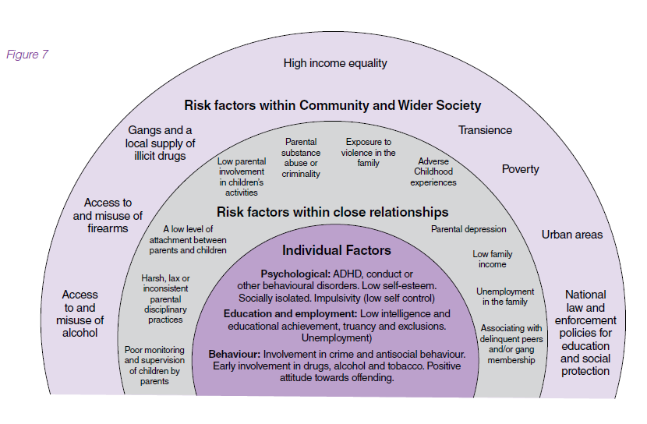

*Figure 1*

1<https://www.who.int/publications/i/item/violence-prevention-the-evidence>

**Nature of Youth Violence**

Youth violence has seen a 21% increase in Lancashire from 2020 to 2021 (violence against the person investigations). Note, due to the COVID-19 pandemic, rates of youth violence were likely to be lower than normal due to lockdown restrictions. This means the sharp increase seen in youth violence is likely to be exaggerated.

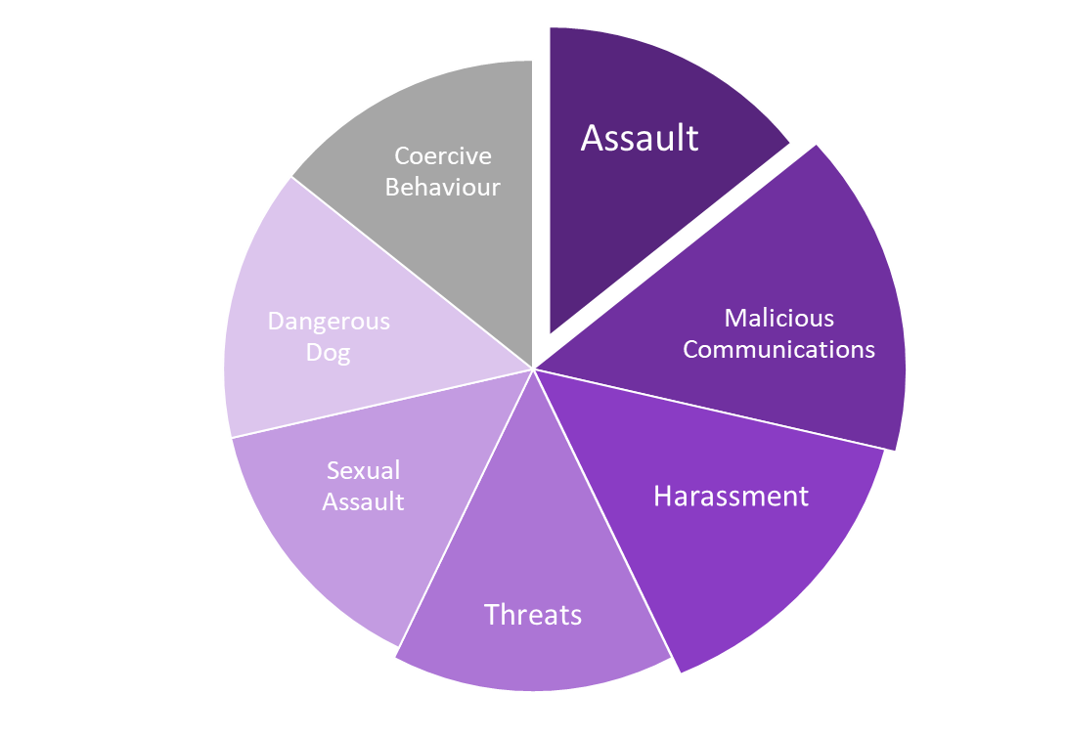However, 2021 still showed an 11% increase from the rate of youth violence in 2019 indicating that the general trend is upward regardless of the pandemic and its lasting impacts.

The aside graphic highlights the key themes within Lancashire based youth violence over the previous 3-year period (2018-2021).

As shown, the most commonly occurring crime type was ‘Assaults’, followed by ‘Malicious Communications’, and ‘Harassment’.

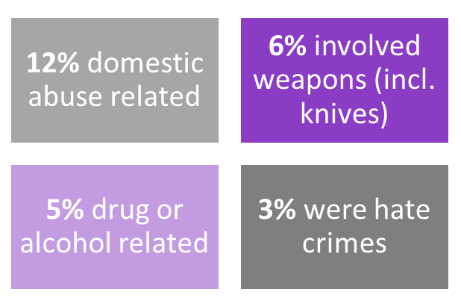

**Youth Violence Consultation**

Expectations to be in a gang

All the comments included are direct quotes from children and young people (8-18) who were involved in the LVRN Youth Violence Commission (146 young people from 32 different organisations covering a wide range of demographics across Lancashire-14). The quotes used are only a small sample of the responses received (595 individual comments in total) but were selected to reflect the key themes that arose when thematic analysis was conducted and therefore highlighting key areas of focus.

**Strategy Links**

1. Prevention strategy (Lancashire Constabulary)
2. Early help strategy (Children’s Social Care)
3. Serious & Organised Crime strategy – 4 Ps
4. Vulnerability strategy (Lancashire Constabulary)
5. Contextual safeguarding (<https://contextualsafeguarding.org.uk/>)

**Risk & Protective Factors**

A public health approach to youth violence focuses on identifying risk and protective factors. These factors are often described across four broad levels: individual, relationship, community and society.

Risk factors can increase the likelihood of a young person offending, however they are not necessarily direct causes, nor are they determinative, meaning that not all young people who are identified as at risk will become a perpetrator of violence or offending.

Risk factors tend to exist in clusters, rather than in isolation. The more risk factors a child is exposed to, the greater the likelihood that the child may become involved in violence, but again involvement in violence is not determinative based on the number of risk factors.

Protective factors for serious violence largely reflect the positive converse of the risk factors. Protective factors can act as a buffer against risk factors. They are conditions, characteristics and influences that may reduce the likelihood of children and young people becoming involved in violence or offending. Protective factors provide an opportunity to build resilience against serious violence.

Figures retrieved from: Public Health England (2019) ‘Collaborative approaches to preventing offending and re-offending in children (CAPRICORN)’ - A resource for local health and justice system leaders to support collaborative working for CYP with complex needs.

**What are the main causes of violence?**

Figure retrieved from: LVRN Youth Violence Commission. Thematic analysis of 146 young people’s responses to a series of questions regarding youth violence knife crime. For the full report, please contact the LVRN.



**More young people feel anxious, down or depressed than ever in the 12-year history of the index, those unemployed being worst affected**

**National Picture**

**Prince’s Trust (Tesco Youth Index)**



**UK young people are 4x as likely to be unemployed than that rest of the working age population**

**65% of NEET feel worse about themselves the longer they are unemployed**

**48% see no end to unemployment**

**1 in 4 feel unable to cope with life (40% for NEET)**

**Half always or often feel anxious (64% for NEET)**

**1/3 always or often feel hopeless (45% for NEET)**

**60% believe a new job is impossible**

The Youth Index is a national survey that gauges young people’s happiness and confidence across a range of areas, from working life to mental and physical health. For the full report, please visit: <https://www.princes-trust.org.uk/about-the-trust/research-policies-reports/research>



**5%**

**7%**

**of pupils had fixed period exclusions – same rate for England** (2019)

**of 16- 17-year-olds are NEET/ activity not known compared to 5.5% in England** (2019/20)

**of pupils have SEN support, compared to 12% in England** (2020)

**69%**



**17%** of children affected by income deprivation – same rate across England (2019)

These headline figures are to provide a snapshot of children and young people in Lancashire, they are not to in anyway present the whole cohort. This data was retrieved from Lancashire Constabulary BI Dashboards, ‘PHE Fingertips’, ‘Lancashire Insight’, and the ‘Local Area Interactive Tool’. All data is reflective of its most recent publication.

**Local Picture**

**Young People in Lancashire**

**of pupils had school readiness, compared to 72% in England** (2019)

**10%**



Similar to the National rate, **1 in 5** people in Lancashire are under 18 (2019)



**Downward trend of first-time entrants (10-17) to the youth justice system**

**193.8 per 10,000 compared to 208.0 per 10,000 across England (2019)**



**22%**

**are re-referred to social care within 12 months of their first referral, compared to 23% in England** (2020)



**2019**

**2020**

**13% of crime committed by 8-18-year olds**

**14% of crime committed by 8-18-year olds**

**1 in 2**

**crimes committed by young people (8-18) are ‘Violence Against the Person’**

**Snapshot of Evidence**

|  |  |  |  |
| --- | --- | --- | --- |
| **Key Insights** | | | |
| **Author and/or organisation** | **Date** | **Title** | **Highlights** |
| World Health Organisation | 2010 | [Violence Prevention: The Evidence](https://apps.who.int/iris/bitstream/handle/10665/77936/9789241500845_eng.pdf?sequence=1&isAllowed=y) | **Strategies for preventing violence:**  - Developing safe, stable and nurturing relationships between children and their parents and caregivers  - Developing life skills in children and adolescents  - Reducing the availability and harmful use of alcohol  - Reducing access to guns, knives and pesticides  - Promoting gender equality to prevent violence against women  - Changing cultural and social norms that support violence  - Victim identification, care and support programmes. |
| O’Connor and Waddell / Early Intervention Foundation | 2015 | [What works to prevent gang involvement, youth violence and crime? A rapid review of interventions delivered in the UK and abroad](https://www.eif.org.uk/report/what-works-to-prevent-gang-involvement-youth-violence-and-crime-a-rapid-review-of-interventions-delivered-in-the-uk-and-abroad) | **What works?**  - Skills-based programmes; family-focused programmes  **What looks promising?**  - Mentoring programmes; community engagement; gang-specific approaches  **What is ineffective?**  - Scare tactics (e.g. prison visits); discipline-based approaches |
| Roberts / Public Health England | 2019 | Approaches to prevent or reduce violence with a focus on youth, knife and gang-related violence | **Primary prevention:**  - Parenting programmes (e.g. Incredible Years Preschool; Incredible Years Age Basic; Empowering Parents, Empowering Communities)  - Home visiting programmes (e.g. Let’s Play in Tandem; the New Forest Parenting Programme)  - Good quality early education and schools-based life and emotional skills training (e.g. Incredible Years Teacher Classroom Management)  - Bullying prevention programmes  - Therapeutic approaches (e.g. multisystemic therapy) for young people at greatest risk  - Changes to firearms policy  - Hotspots and community or problem-orientated policing  **Secondary and tertiary prevention:**  - Therapeutic approaches for young people; hotspots and community or problem-orientated policing; restorative justice |

**Youth Endowment Fund Toolkit**

See below an overview of existing research on approaches to preventing serious youth violence, with high and moderate estimated impact as of December 2021.

**COST**

**EVIDENCE QUALITY**

**ESTIMATED IMPACT ON VIOLENT CRIME**

**Cognitive behavioural therapy**

**COST**

**EVIDENCE QUALITY**

**ESTIMATED IMPACT ON VIOLENT CRIME**



A talking therapy which helps people recognise and manage negative thoughts and behaviours.

**Mentoring**

**COST**

**EVIDENCE QUALITY**

**ESTIMATED IMPACT ON VIOLENT CRIME**



Matching children and young people with mentors who provide guidance and support.

**Pre-court diversion**



Diverting children who have committed first-time or low level offences away from the formal youth justice system.

**Restorative Justice**

**COST**

**EVIDENCE QUALITY**

**ESTIMATED IMPACT ON VIOLENT CRIME**



A process which supports someone who has committed a crime to communicate with the victim, understand the impact of their actions, and find a positive way forward.

**Social skills training**

**COST**

**EVIDENCE QUALITY**

**ESTIMATED IMPACT ON VIOLENT CRIME**



Aims to develop children’s ability to regulate their behaviour and communicate effectively.

**COST**

**EVIDENCE QUALITY**

**ESTIMATED IMPACT ON VIOLENT CRIME**



**Focused deterrence**

A strategy that combines communicating the consequences of violence with support for developing positive routes away from it.

**HIGH**

**HIGH**

**MODERATE**

**HIGH**

**MODERATE**

**MODERATE**

**Action Plans**

**Reducing Serious Youth Violence**

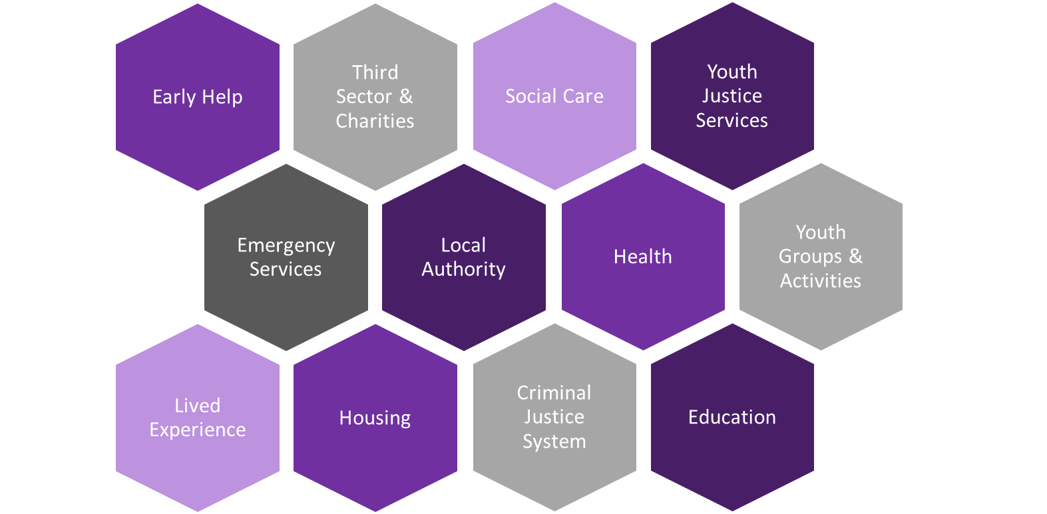

**What do you think could be done to solve the problem with youth violence and knife crime?**

Figure retrieved from: LVRN Youth Violence Commission. Thematic analysis of 146 young people’s responses to a series of questions regarding youth violence knife crime. For the full report, please contact the LVRN.

**Pan Lancashire Early Help Service Offer (July 2022)**

**ACTION AREAS**

The Pan Lancashire approach to Early Help incorporates the Lancashire County Council, Blackburn with Darwen Council and Blackpool council.

**Partnerships**

Pan Lancashire Early Help teams will be key in bringing together local partners and multi-agency teams to support the engagement of young people and families at an operational and strategic level via the continued roll out of the Supporting Families (Troubled Families) agenda, Team around the Family and Team around Schools and Settings. By ensuring the co-creation and co-delivery of interventions we will enable a direct response with no duplication. Multi- agency teams will deliver in community settings that children and their families trust within Schools and the roll out of Family Hubs. Family Hubs will provide a single access point, a universal “front door” to services.

**Identification**

Pan Lancashire Early Help and Specialist Support will continue the early identification of young people at risk of serious youth violence, victims or perpetrators via either the MASH (Multi Agency Safeguarding Hub) / CSSH (Children's Services Safeguarding Hub), CADS (Children's Advise and Duty Service) or Request for Support Hub and our front-line teams within Early Help, Intensive Family Support and Targeted Youth Support. This will be achieved via the use of the CAF, Early Help Assessment and / or Family Assessments identifying key risk and protection factors that enable an accurate referral or signpost to be undertaken.

**Workforce Development**

Our workforce development plan will include continued delivery of key themes that all front-line team will need to support young people and families at risk of serious youth violence including Trauma Informed, ACE (Adverse Childhood Experiences), assessment and analyse, drug and alcohol and motivational interviewing. We will use data from partners and our own referrals to identify trends within this area to ensure a continued.

**Delivery**

We will delivery our targeted approach to both group work and 1:1 interventions in a Pan Lancashire approach via the use of evidence based programs. Our Family Support teams work within a whole family approach and use ACE-informed and systemic practices to underpin their work.





**Pan Lancashire Youth Justice Service Offer (December 2021)**

Pan Lancashire Youth Justice Services are multi agency teams compromising of Social Worker, Youth Justice Workers, Restorative Justice Workers, Probation Officers, Police Officers, Health (emotional and mental health, physical health, speech and language and substance misuse workers), Education, Training and Employment workers.

Pan Lancashire Youth Justice Services offer work around prevention of offending and re-offending to children and families, working with children aged 10-17[1] in a child first, trauma informed and restorative approach. These services are either delivered directly by the youth justice service or via associated services, depending on locality.

**Actions**

1. Targeted prevention of offending with child and parent/carer referred from police, social worker and school (delivered via Youth Justice Services or other local associated services).
2. Pan Lancashire Youth Justice Services provide multi agency interventions and supervision for children convicted of violent offences to prevent reoffending, based on research of what works.
3. Pan Lancashire Youth Justice Services provide support to victims of children who have committed violent offences.

Blackburn with Darwen, Blackpool and Lancashire Youth Justice Teams all have a detailed multi-agency Youth Justice Plan which sets out their service delivery and action plans, these are completed on an annual basis.



**STRATEGIC PRIORITIES**

**Participation**

CYJS will listen to the voice of the child, families, and victims to offer the opportunity to actively participate in the service delivery and improvement.

**Health**

CYJS will continue to provide a clinical psychologist to undertake staff consultations and multi-agency formulation meetings from a trauma informed lens for children with complex needs. CYJS will continue to provide multi-disciplinary health services to children known to the service including emotional health and wellbeing, speech and language and substance misuse services.

**Prevention and Diversion**

CYJS will continue to provide a Child First Prevention and Diversion scheme to contribute to preventing serious youth violence. Including contributing to the early help offer to children following repeat arrests by the Police with no further action and enhance the groupwork offer of the Community Football Trusts. CYJS will continue to contribute and support the development of the Multi Agency Support Panel and Team Around the Schools and Settings, to contribute to the prevention of serious youth violence. CYJS will continue to work alongside children's services partners to develop the Adolescent Strategy including Lancashire's Contextual Safeguarding Team, Education, Children and Family's Wellbeing services.

**Need, Risk and Intervention**

CYJS will ensure all assessments and interventions are underpinned by the services core principles of child first, trauma informed, and restorative approaches. CYJS will develop their interventions to further address serious youth violence and will continue to provide restorative justice services to children known to the service and the victims of their offences. CYJS will continue to provide a multi-agency tailored plan for children who make a transition, for example, children who are resettling into the community from a custodial setting or transitioning to adult services.

**Partnership working**

CYJS will continue to collaborate with Lancashire's Contextualised Safeguarding Team, Community Safety Partnerships, and Police to share information to address serious youth violence, child criminal and sexual exploitation concerns.

**Education, training and employment**

CYJS will continue to attend Missing from Home and Missing from Education meetings for vulnerable children to ensure targeted activities and interventions are in place to reduce risk and support children into education, training or employment.

**Data**

CYJS will continue to use data and intelligence from a range of sources to improve understanding of serious youth violence and work with partners to share information, analyse and learn.



**STRATEGIC PRIORITIES**



**Health**

Ensure a high level of specialist support is available to meet the physical, emotional and mental health needs of our young people, including access to speech and language provision.



**Education, Training and Employment**

Raising the aspirations of our young people through access to education, training and employment provision that meets their needs and interests.



**Prevention**

Develop the role of prevention services within the YJS and strengthen links to partner agencies, providing holistic support to young people to prevent entry into the criminal justice system.



**Participation**

Increase opportunities for young people to contribute to service and system design and delivery through their feedback.



**Need and Risk**

Ensure that a ‘child first’, ‘trauma informed’ approach is taken to assessing the needs and risk of young people; and for them to have access to appropriate interventions to mitigate the impact.



**Quality Assurance and Governance**

Establish a quality assurance framework that recognises good practice, identifies areas for individual and team development and provides assurance to the Youth Justice Partnership Board of adherence to the Standards for Young People in the Youth Justice Service.

Blackpool Youth Justice Team

**STRATEGIC PRIORITIES**

**Data**

Use localised data to monitor trends and behaviours to formulate responses by offence type, geography etc.

**Delivery**

Develop an agreed protocol and shared understanding across the partnership for managing contextual safeguarding at the operational level. Daily representation at the DEM (daily exploitation & missing from home meeting) in order to work collaboratively with Awaken (Blackpool’s Contextual Safeguarding Team), Community Safety Partnerships and the Police to assist in addressing concerns for children and young people at risk of criminal and sexual exploitation and/or missing from home who may be more likely to be at risk of serious violence.

**Prevention & Intervention**

Continue to develop and deliver targeted interventions with individual children related to a specific offending behaviour type e.g. violence, knife crime, harmful sexual behaviour etc. through a co-produced bespoke plan for the child. Provide targeted support to schools to prevent school exclusions related to offending behaviour.

**Participation**

We will encourage children, young people, and their parent/ carers active participation, engagement and wider social inclusion to ensure that all work is co-created.

**Need and Risk**

Blackpool YJS will listen to children, encourage active participation by putting them at the centre of all the work we do so we can build trusting relationships that empower children to fulfil their potential and make positive contributions to society. We will undertake an assessment of each young person to identify and understand any risk to the individual or risk they may pose to others. Deliver interventions and supervision to ensure the needs of all children and young people involved with Blackpool (YJS) are met.

**Partnership**

The Blackpool Youth Justice Executive Management Board is committed to working effectively and collaboratively with all relevant partners and agencies to reduce the numbers of children and young people entering the criminal justice system and to reduce re-offending.

**Further resources:**

* World Health Organisation (2015) [Preventing youth violence: an overview of the evidence](https://www.google.com/url?sa=t&rct=j&q=&esrc=s&source=web&cd=&ved=2ahUKEwid4eug7rLxAhW1nFwKHUJCDTAQFjABegQIBhAD&url=https%3A%2F%2Fapps.who.int%2Firis%2Frest%2Fbitstreams%2F812736%2Fretrieve&usg=AOvVaw37m6ypX-shIbPwe-HTVBII)
* Early Intervention Foundation (2015) [Preventing Gang and Youth Violence](https://www.eif.org.uk/report/preventing-gang-and-youth-violence-spotting-signals-of-risk-and-supporting-children-and-young-people)
* David-Ferdon et al. (2016) [A Comprehensive Technical Package for the Prevention of Youth Violence and Associated Risk Behaviours](https://www.cdc.gov/violenceprevention/pdf/yv-technicalpackage.pdf)
* Early Intervention Foundation (2017) [Early Intervention Foundation Guidebook](https://guidebook.eif.org.uk/)
* Children’s Commissioner (2019) [Keeping kids safe: Improving safeguarding responses to gang violence and criminal exploitation](https://www.childrenscommissioner.gov.uk/wp-content/uploads/2019/02/CCO-Gangs.pdf)
* Public Health England (2019) [Collaborative approaches to preventing offending and re- offending in children (CAPRICORN)](https://assets.publishing.service.gov.uk/government/uploads/system/uploads/attachment_data/file/828228/CAPRICORN_resource.pdf)
* Youth Endowment Fund Toolkit (2021) <https://youthendowmentfund.org.uk/toolkit/>
* [Lancashire Children, Young People and Families Partnership Board - Lancashire County Council](https://gbr01.safelinks.protection.outlook.com/?url=https%3A%2F%2Fwww.lancashire.gov.uk%2Fpractitioners%2Fsupporting-children-and-families%2Flancashire-children-young-people-and-families-partnership-board%2F&data=04%7C01%7CTeigan.Whiffing%40lancashire.police.uk%7Cabc6339db425499abab008d9e7f8c892%7C5c524f103c77423d8c82842fc2a22afb%7C0%7C0%7C637795877960719740%7CUnknown%7CTWFpbGZsb3d8eyJWIjoiMC4wLjAwMDAiLCJQIjoiV2luMzIiLCJBTiI6Ik1haWwiLCJXVCI6Mn0%3D%7C3000&sdata=TxkwanW6g7tt5katNfGC6Ft12Sa5t9dZp3V5mfxwEpM%3D&reserved=0)
* [Children and Young People’s Emotional Wellbeing and Mental Health Transformation Plan - West Lancashire Borough Council (westlancs.gov.uk)](https://gbr01.safelinks.protection.outlook.com/?url=https%3A%2F%2Fwww.westlancs.gov.uk%2Fmore%2Fhealth-and-wellbeing%2Fchildren-and-young-people-s-emotional-wellbeing-and-mental-health-transformation-plan.aspx&data=04%7C01%7CTeigan.Whiffing%40lancashire.police.uk%7Cabc6339db425499abab008d9e7f8c892%7C5c524f103c77423d8c82842fc2a22afb%7C0%7C0%7C637795877960719740%7CUnknown%7CTWFpbGZsb3d8eyJWIjoiMC4wLjAwMDAiLCJQIjoiV2luMzIiLCJBTiI6Ik1haWwiLCJXVCI6Mn0%3D%7C3000&sdata=a5Fzkj2RZ3FXaf%2FHqamwY49r6r5dtcJC6j11qco2yv4%3D&reserved=0)

1. Lancashire CYJS offer prevention intervention for children from 8 years old.